# **Imagemaking in Graphic Design: Definition & Importance**

## **What is a Graphic Design Image?**

[**Graphic design**](https://study.com/learn/lesson/what-is-graphic-design.html) is one of the most important art forms and methods of communication in today's world. From selling merchandise to branding to communicating ideas effectively, graphic designers and the work they create can make or break many endeavors. Graphic design is a craft where images and text are aesthetically formed to communicate information and ideas to a larger audience. Graphic designers use a series of principles to create their work and make artistic decisions based on the needs of both clients and users so information is engaging and consumable. Principles and elements used by graphic designers include color theory, page layout, typeface design, and an understanding of the user experience. By utilizing all these elements, graphic designers create advertisements, website layouts, and informational media that meet client goals and appeal to the user.

Images are one of the most important features of graphic design. They say a picture is worth a thousand words, and it also may be said that no one knows this better than a graphic designer. Images not only show what is for sale but can communicate ideas even without the use of words. Images are naturally eye-catching, as humans can be described as visual creatures, and can provide an automatic hook for users and consumers. A graphic design image is defined as an image that is used to convey a message. Graphic design images can be photographs or can be carefully crafted illustrations.

## **Understanding Graphic Design Images**

**Images** in graphic design are used to convey certain ideas. Advertisements, organizations, companies, and all sorts of other people who have items to sell or ideas to convey use images in their graphic designs to hook an audience and draw their attention, while also conveying information or messages that the producer wishes to say. Graphic design images are chosen to make specific points or to serve specific purposes. In this way, images in graphic design are more than just aesthetically pleasing; producers and graphic designers work together when choosing and planning images to use and make decisions on what images to use based on the intention of the graphic.

To start with, graphic designers usually get information about the desired effect the producer wishes to evoke in the audience. Art elements such as theme, mood, and color theory are considered when creating the design layout and aesthetics of the design. For example, for an advertisement about food, images need to be selected that showcase the food in a way that looks appetizing. For a pamphlet, however, included images may need to be more informational. Again, the intention behind the design will drive the majority of the design decisions.

### **Why is Graphic Design Important?**

Graphic design is very important in several fields. In advertising, images are designed to give information about the product, including what it looks like, how it looks when interacting with people, how much money the item costs, and where it can be found. In informational spaces, such as pamphlets, magazines, newspapers, and even informational texts, the graphic design uses images that relate to the text, and often provide a unique way of understanding the information. In social media spaces, graphic design is vital to attract the attention of users among a sea of other images. Images in graphic design are also important to use when raising awareness about an issue, as images of the issue often move audience members to act.

## **Types of Graphic Art Images**

There are many different types of images in graphic design. Generally, graphic design images are either photographs or illustrations, and the decision to use either is driven by the purpose of the media. No matter which type of image is used by a graphic designer, there are ways of editing images so they fit the aesthetic of the project. Image editing software is often used to edit images for the images to fit in the layout of the design.

When using photos in graphic design, sometimes photographers are hired to create the desired photograph needed for a certain design. Photoshoots require a substantial amount of resources such as a photographer, models, props, and other subjects, a photography crew, and a location in which to shoot photos. When these resources are not available, however, graphic designers use what is known as stock images that are either free or low in cost. By using stock images, graphic designers can pick from a huge library of images that suit almost any need.

Illustrations are also made and used by graphic designers. Graphic design illustrations are beneficial because the graphic designer can make an image of almost anything, and often stylized illustrations can fit seamlessly into the aesthetic the designer lays out. The drawbacks of illustrated graphic design images are they can range in quality, and not every graphic designer illustrates as well. If illustrations are needed for an image and the graphic designer cannot produce them, they may have to hire an illustrator or find stock illustrations.

Images are also sorted by the way they are used in graphic design. There are two types of uses for images. One type is known as denotative images, and the other type is known as connotative images.

### **Denotative Images**

**Denotative images** are images that require no interpretation and are images depicting a simple representation of the object. Denotative images have no deeper meaning. For example, a car advertisement shows an image of a car simply because it is selling the car. The car does not represent some other idea, it is simply a car. The image may show a stylized image of the car, perhaps in a desirable location and displaying the various amenities and abilities the car has, but the image does not elicit an artistic mood or theme.

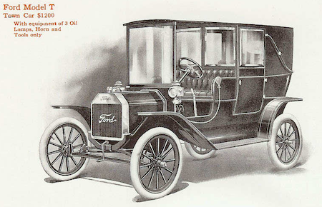

***A 1911 advertisement of a Ford Model T is an example of a denotative image.***

### **Connotative Images**

**Connotative images** are images that depict objects or subjects that have a deeper meaning. There are often layers of meaning in connotative images, and the subjects and schenes depicted in the image have multiple meanings. They usually give the viewer a broader context and involve a deeper situation than denotative images. They also include a variety of artistic principles, such as theme, mood, and atmosphere. Additionally, connotative images must rely on the ability of an audience to understand the message the image implies. Because of this, language and cultural context are an important part of using connotative images.

An example of a connotative image includes advertisements for products that are situational, such as participants happily using a product. The emotions displayed by the models imply that using the product will bring about happiness. This is a classic advertising technique and is used to sell all sorts of materials, depending on the emotion the image depicts.

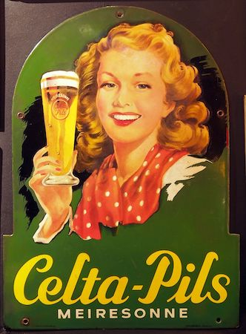

***This happy woman holding a glass of beer used in a beer advertisement is an example of a connotative image.***